Create a VPC security group for a private DB instance

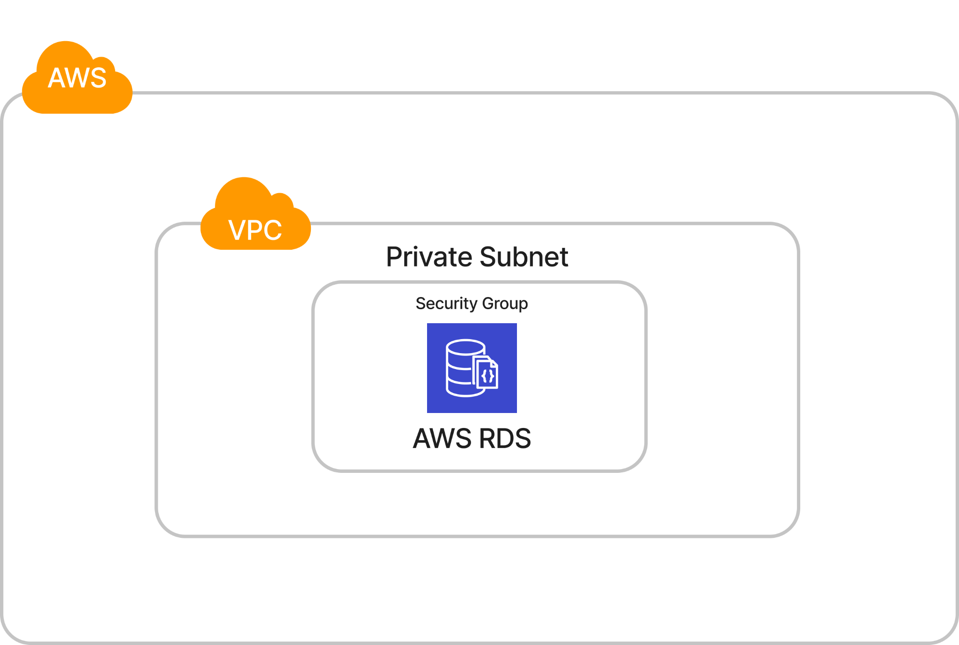

Here’s the custom security group (cus_pri_db_sg) inside my custom VPC for RDS

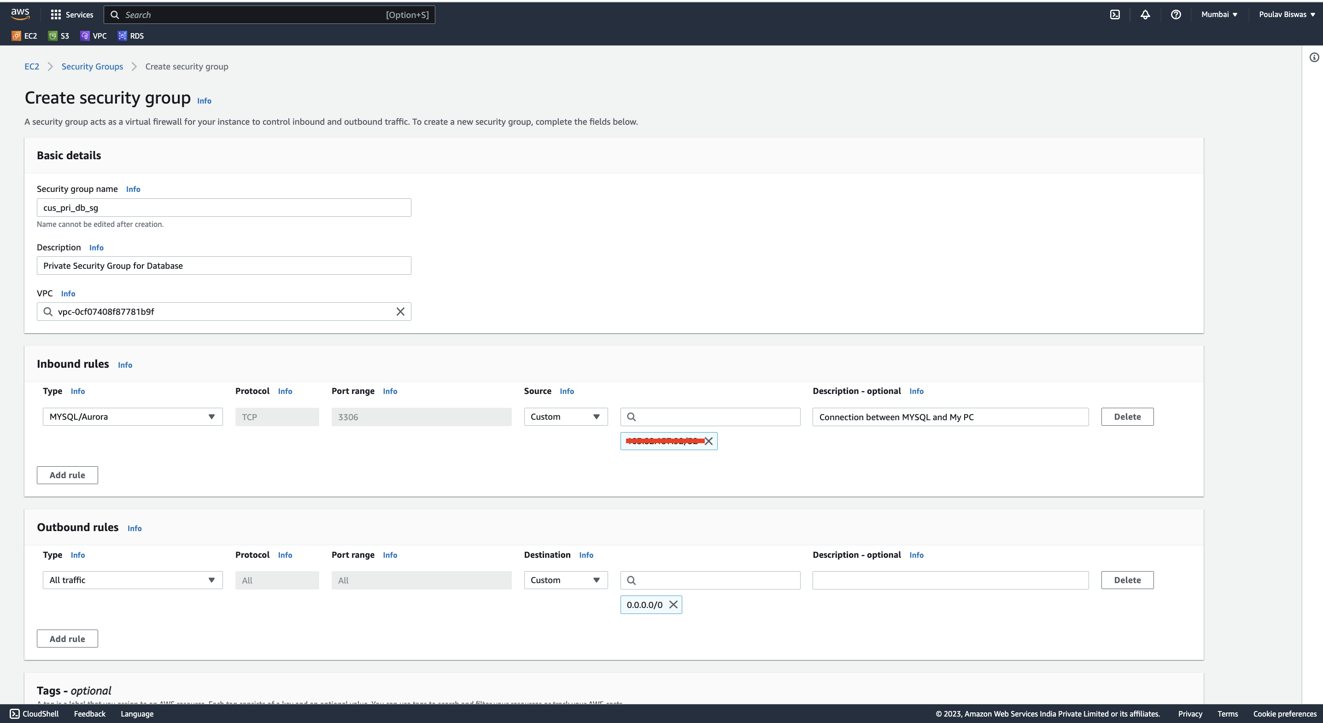

Now, if I want to connect to an existing EC2 instance, I can do that by going through the interface on amazon’s console which will create two different security groups which will allow connection to and from the EC2 and RDS.